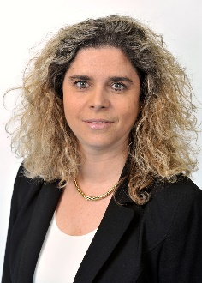
Nathalie de Marcellis-Warin

Full Professor, Polytechnique Montreal

Chief Executive Officer, CIRANO (Center for Interuniversity Research and Analysis of Organizations)
Holder of a Ph.D. in management science (in risks and insurance management) from École Normale Supérieure de Cachan (France), Nathalie de Marcellis-Warin is Full Professor in the Department of Mathematical and Industrial Engineering of Polytechnique Montréal. She is Visiting Scientist, Harvard Center for Risk Analysis, Department of Environmental Health, Harvard T. Chan School of Public Health.
In 2011, she started the Barometer CIRANO on risk perception in Quebec, which collects yearly data about Quebec’s population preoccupations.

Her research interests are risk management and decision theory in risk and uncertainty. Her current research projects are focused on risk perception and social acceptability of public decisions,hazardous material transportation, health and environmental risks, and emerging risks and risks related to collaboration in R&D. Her research methodologies combine economic analysis, cost-benefit analysis, surveys and unstructured data analysis (related to a research project with Harvard).

