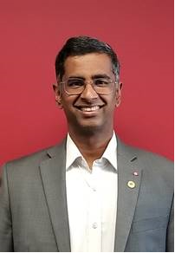
Ravi Sundararaj

Senior Director of Infrastructure Asset Management

Public Services and Procurement Canada (PSPC)

Ravi Sundararaj is PSPC's Senior Director of Infrastructure Asset Management, responsible for the national operations of Engineering Assets and for leading the initiative for the Protection of Underground Infrastructure. Mr. Sundararaj has held a number of management roles, most recently the Service Delivery Executive for Science, with responsibility for national Real Property service delivery; and previously, the Senior Director for Professional & Technical Services, responsible for Project Delivery and Architectural, Engineering, Geomatics and Environmental Services in the NCA. He is a Professional Engineer, with a B.Sc. in Civil Engineering from the University of Alberta, and a Master's in Structural Engineering from the University of Toronto.

