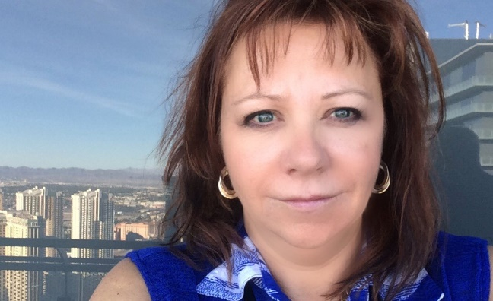
Debbie Shelley

CEO

Global Training Centre
Driven by a heart wrenching experience of a fatality on her team, Deb pursued a way to make a difference! She found it in learning and development and helping people believe in their “right” AND their “obligation”, to go home - every day safe and sound.

Currently the CEO of the Global Group of Companies - which has developed hundreds of training programs for the Fortune 500 companies, and trains thousands of leaders and workers every year. Additionally, Debbie is utilized by some of the largest companies in the world, in developing their leadership teams.

Specific to us at the Common Ground Alliance - Debbie has worked countless hours (years actually), in the development of the damage prevention training standard within Alberta, just recently BC, and soon Manitoba, giving her an in depth understanding of what Damage Prevention actually requires.

Deb has travelled and delivered the safety and leadership message in dozens of countries on every continent in the world (except Antarctica – apparently the penguins don’t need development). All of this has given her a unique perspective on “what is” the universal language of safety, and how to develop and then deliver learning that creates change and makes a difference!

