Darcy Hurlock

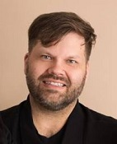
Cable Locate Support Centre Operations

TELUS
Darcy currently manages the Cable Locate Support Centre within TELUS, covering locates of all TELUS buried facilities from British Columbia to Ontario. He is also the Chair of the Alberta Common Ground Alliance and participates in many other consortiums and associations related to damage prevention.

780.218.4720
darcy.hurlock@telus.com
www.telus.com

