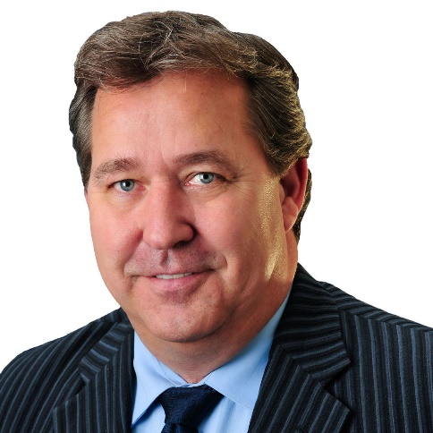
Darwin Durnie

Darwin Durnie, RET, is a leader in the delivery of services in municipal operations, administration, and legislation in Alberta with over 36 years of hands on and strategic experience. Emergency and disaster management are a true passion for Dawrin who has committed 25 years of his career to helping clients prepare for or manage these crisis situations. He has provided strategic leadership to Canada’s three largest natural disaster events; 2011 Slave Lake Fire, 2013 High River Flood and 2016 Fort McMurray Wildfire. He also worked for the Government of Canada as the Site Manager at the 2002 G8 Summit in Kananaskis and the 2010 G8 and G20 Summits in Deerhurst and Toronto. Darwin is also past president of the Canadian Public Works Association and was awarded the Public Works Leader of the year in 2015 from the American Public Works Association.

