Adam Blanchard

President and Founder

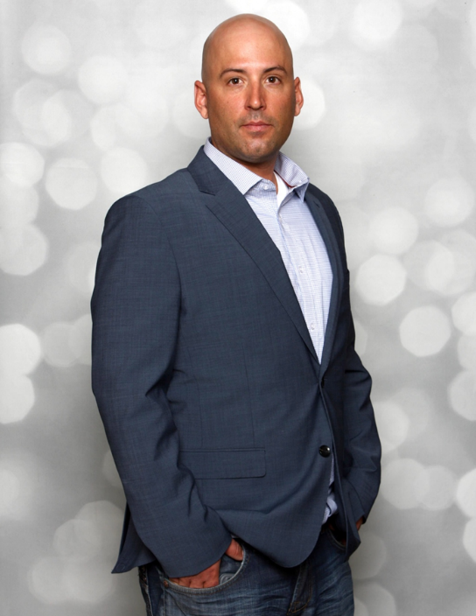
Safe Locate Solutions

Over the past 15 years Adam Blanchard has spent his career continuously advancing his capabilities and knowledge towards asset integrity management as it relates to buried facilities and damage prevention. As part of his drive to improve and streamline current practices, he's made it his goal to have a detailed understanding of new innovative technologies and how they can add value to the sector. Having identified numerous inefficiencies in traditional project execution, Adam is constantly researching new and innovative systems that will positively impact the safety culture, environmental footprint and overall efficiency of the utility sector's efforts.

