Duane Rodgers

CEO

PelicanCorp

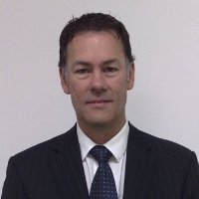
As CEO of PelicanCorp, I have been heavily involved in influencing the growth and expansion of our Australian-based company in New Zealand, Singapore, United Kingdom, Ireland, United States and Canada. With more than 27 years experience in Damage prevention and starting as a computer software engineer, we focus of the technology to engage the market.

With a complete platform of solutions for Essential Asset Protection, the PelicanCorp team has taken this niche business of utility, local government and municipality asset protection to being the only global solution provider to this industry.

I am passionate about our people and our market segment, and continue to develop key ideas for the future of our industry.

I continue to learn and develop the skills, and team needed to expand the PelicanCorp business across the globe. I continue to balance the growth, acquisition and product and service offerings that PelicanCorp has targeted to achieve our International goals.

+1 (203) 747 1365
duane.rodgers@pelicancorp.com

