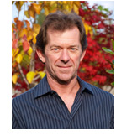
Bio for Bruce Hunter
An industry leader in landscape design and installation, Bruce boasts over 30 years of design and installation experience. Hunter Landscape Design has earned many Awards for Landscape Excellence. Bruce spent many years working with consultants and associations at the provincial national and international levels developing and implementing the current Landscape Industry Certification programs. Bruce is currently the President of the Canadian Nursery and Landscape Association (CNLA), Bruce is currently one of two people in Canada recognized as Landscape Industry Certified as a Manager, Designer, and Technician for Hard and Softscape Installation.

